|  |
| --- |
| Asia_Pacific_College_Logo.png |
| Resources for the Blind – Inventory System |
| Software Development |
|  |
| **Clarence Carillaga**  **Pauline Gabrielle De Ocampo**  **Phil Harvey Burgos** |
| **APRIL 2015** |

Table of Contents

[BACKGROUND OF THE CLIENT 3](#_Toc416220041)

[BACKGROUND OF THE PROJECT 3](#_Toc416220042)

[REVIEW OF THE ITERATIONS 5](#_Toc416220043)

[Iteration 1 5](#_Toc416220044)

[Iteration 2 6](#_Toc416220045)

[BRIEF OUTLINE OF THE INDIVIDUAL MEMBER CONTRIBUTIONS TO THE PROJECT 7](#_Toc416220046)

[Github Project Repository Page 7](#_Toc416220047)

[Github Project Repository Charts 7](#_Toc416220048)

[Individual Contributions 8](#_Toc416220049)

[Most Recent Commits 8](#_Toc416220050)

[One commit (Diff) 10](#_Toc416220051)

[CURRENT STATUS OF THE PROJECT 11](#_Toc416220052)

[Percent Completed 11](#_Toc416220053)

[Remaining Work to Be Completed 11](#_Toc416220054)

[Client Feedback Regarding their Interest 11](#_Toc416220055)

[NEXT STEPS TO TAKE 12](#_Toc416220056)

# BACKGROUND OF THE CLIENT



**Resources for the Blind Inc.** is a non-profit and non-government Christian organization that serves the visually-impaired people since 1988. They devoted themselves in removing the obstacles and providing services, training, and equipment needed in order for those who are visually-impaired to reach their fullest potential in life.

#### Mission

To design and implement programs that will enable those with visual impairment to understand and reach their God-given potential in life and service.

#### Vision

All Filipinos who are visually impaired will be able to reach their fullest potential in life and in ministry that God has for them.

# BACKGROUND OF THE PROJECT

**Problem Statement**

Selling assistive devices for the visually impaired and low vision individuals is one of Resources for the Blind Inc.’s offered service. Most of the devices they sell are imported because there are some devices that are not locally available. For new assistive items, The sales coordinator searches it over the Internet and look for possible suppliers. On the other hand, the existing items are provided by their former suppliers.

Before placing the order, they would have to inquire if the said item is still available. If it is, they would request a quotation, which would be approved by the RBI heads. The purchasing and payment of the order would be done after the approval while the pricing of the items are done by the accounting department.

To make the work faster and more efficient, the RBI wanted an inventory system that could monitor its daily sales transaction and replace its current manual system of managing in-stock devices.

**Proposed Solution**

The proposed Inventory system would be monitoring the daily transactions of Resources of the Blind, Inc. There should be a list of existing products, suppliers and customers for easier order inquiry. It is also important to note that since the organization hires visually-impaired employees, the system should be simple and easy to use. The system then, would have to be accessed with the use of arrow buttons, tab button, shortcut keys and buttons with labels. In addition to these, it should also be able to generate annual transactions and orders to suppliers report.

**Project Purpose**

The group's vision as the project purpose is to be able to create an Inventory System that will monitor Resources for the Blind's daily transactions and provide a friendly interface for both sighted and visually-impaired.

**Project Objectives**

**Short Term Success Objectives**

1. *Improved accessibility of files and records.* The system should be able to show the product, sales, supplier and customer information.  
2. *Convenience in tracking and retrieving items.* The user should be able to keep track of the number of available and out-of-stock items.  
3. *Monitor transactions easily.* The system should be able to keep track of each customer’s transactions and show the day-to-day sales of the organization.

**Long Term Success Objectives**

1. *Accurate, precise and improved auto-generation of monthly and annual sales and inventory report.* The system should be able to generate a report which can include all transaction and item records from the database.  
2. *Blind and visually-impaired friendly interface.* The system’s interface should be easily manipulated; the controls will be composed mostly of tab keys, arrow keys and buttons with labels.  
3. *Make work efficient and convenient for the client stakeholders.* The system’s main goal is to get the job done in an efficient and effective way.

**Target Users**

The **Sales Coordinator** of Resources for the Blind, Inc. will be the one to use the system in order to manage and encode the data and information for their daily transactions.

**Expected functions and modules of the system:**

**Item Records**

* Shows items
* Shows the product information *(details about the product, such as, name, price, quantity, etc.)*
* User can add, modify and delete product information

**User Information**

* Show customer information *(personal details about the customer, such as, customer name, address, contact, etc.)*
* Show supplier information *(personal details about the supplier, such as, supplier name, address, contact, etc.)*
* The user can add, modify, and delete customer information
* The user can add, modify, and delete supplier information

**Order Records**

* Show order to suppliers’ information *(item name, quantity ordered, etc.)*
* The admin can add, modify, and delete order information
* Generate a report based on annual orders

**Purchase Records**

* Show customers' purchases information *(item name, amount, quantity ordered, etc.)*
* The admin can add, modify, and delete order information
* Generate a report based on the annual transactions

# REVIEW OF THE ITERATIONS

## Iteration 1

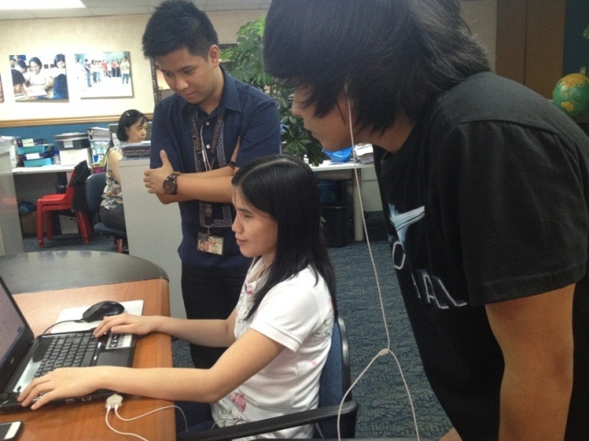

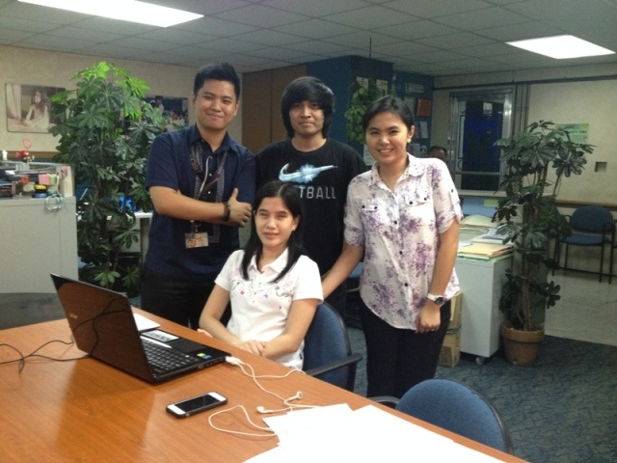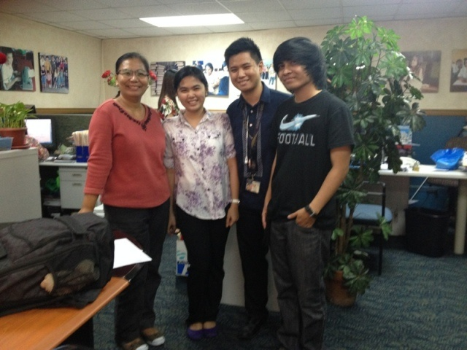

***For the documents, please refer to the Appendices.***

## Iteration 2

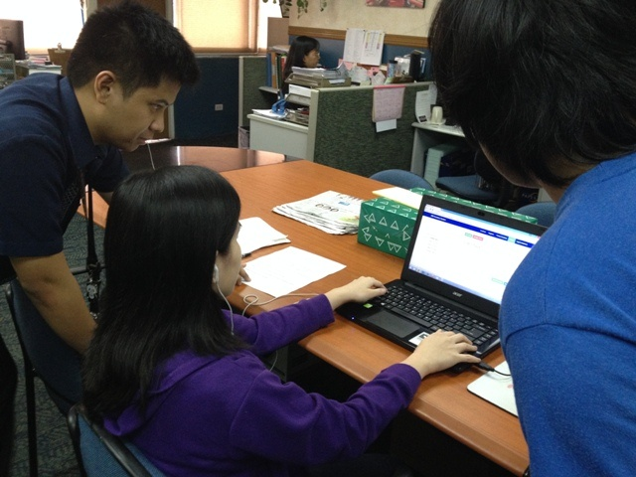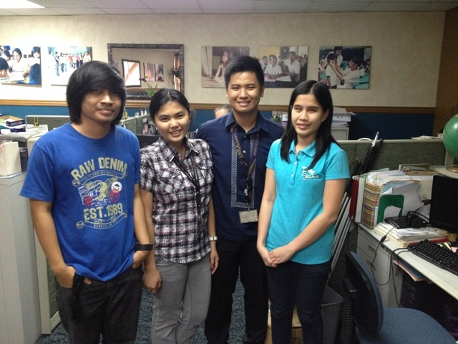

***For the documents, please refer to the Appendices.***

# BRIEF OUTLINE OF THE INDIVIDUAL MEMBER CONTRIBUTIONS TO THE PROJECT

## Github Project Repository Page

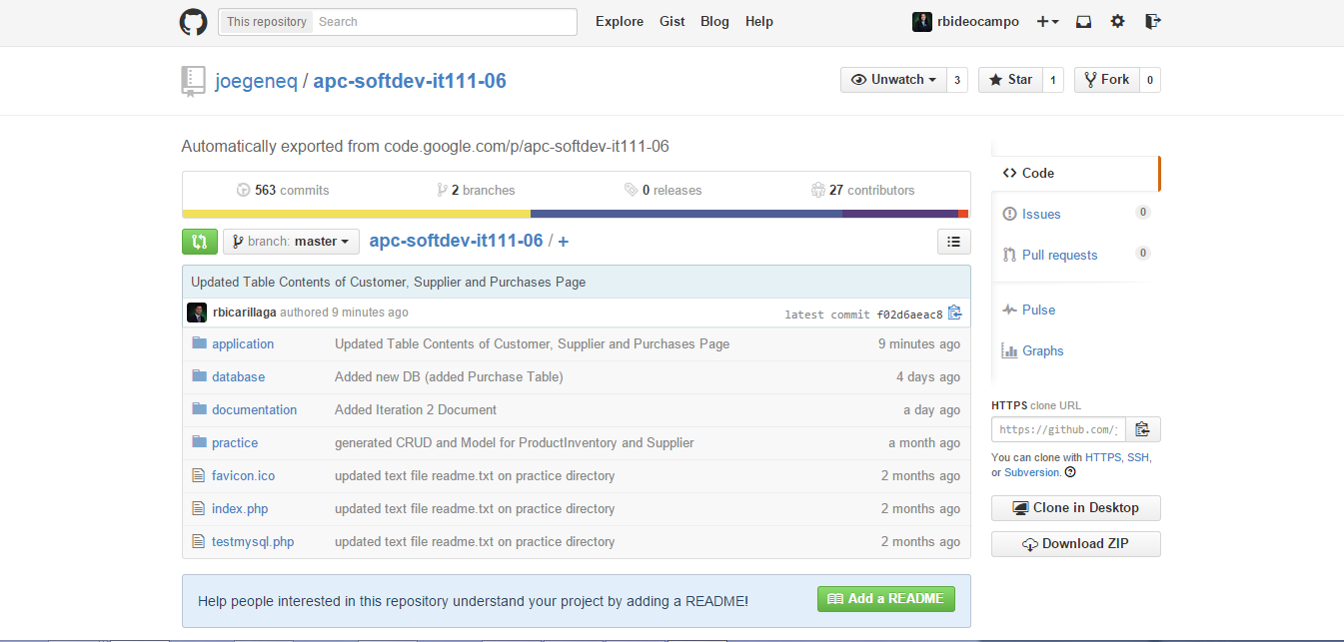

## Github Project Repository Charts

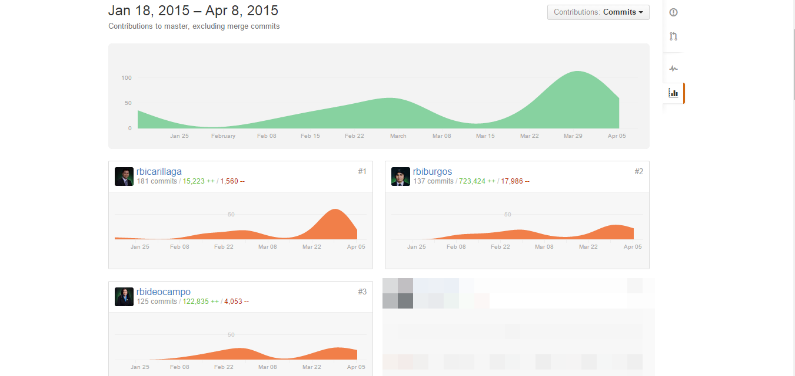

## Individual Contributions

**Clarence Carillaga:**

* + Overall UI Design (Images, logos, color, buttons with labels)
  + Access keys
  + Screenreader idea and download
  + Help page

**Pauline Gabrielle De Ocampo:**

* + Database design / structure
  + Calculated fields (multiply function for Purchase and Deduct function for Product Inventory)
  + Link Names (link to view)
  + Dropdowns (References, Status, Type, Country)

**Phil Harvey Burgos:**

* + Generate Report (Order and Purchases, confirmed filter for Purchases)
  + Manage (All tables)
  + Log In
  + Session
  + Getting Started page

## Most Recent Commits

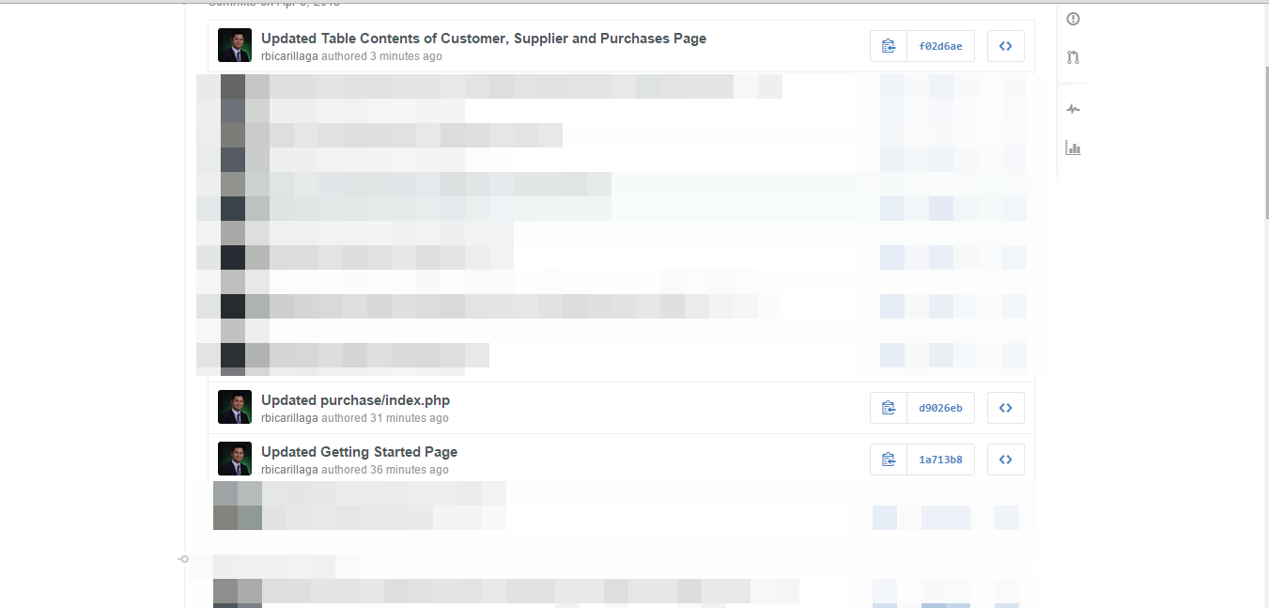

*Clarence’s Recent Commit*

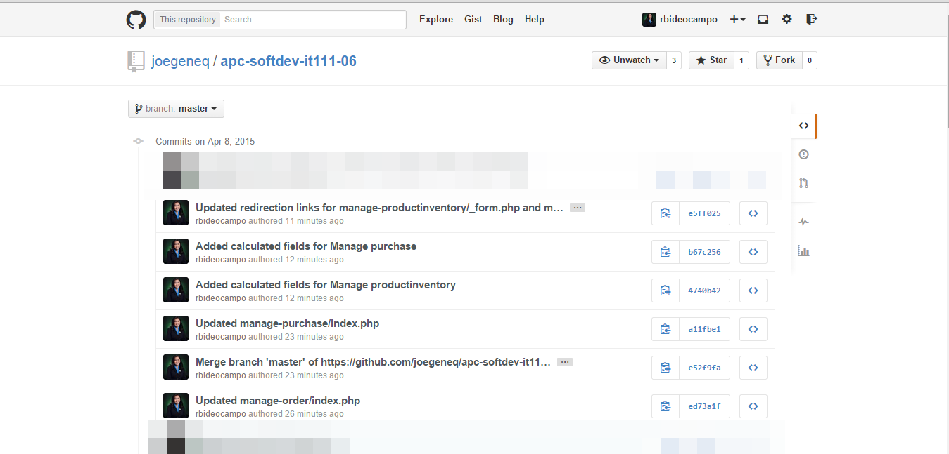

*Pauline’s Recent Commits*

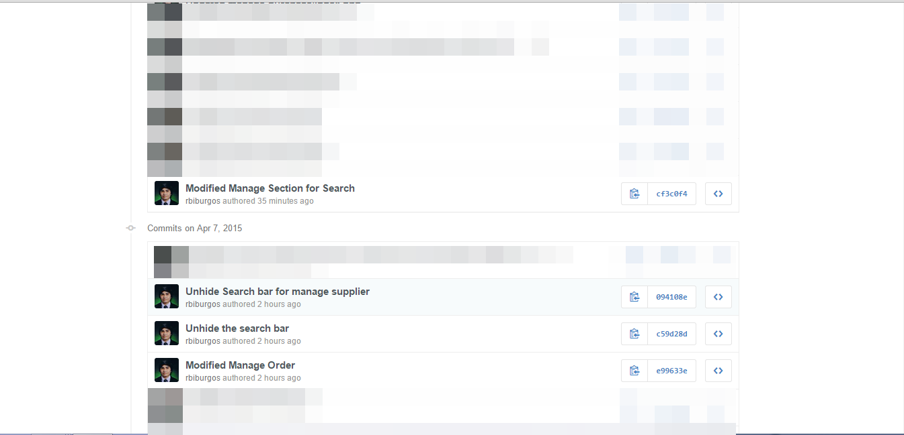

*Phil’s Recent Commits*

## One commit (Diff)

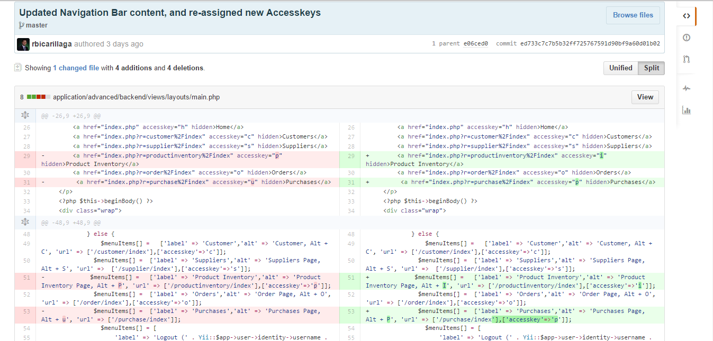

*Clarence – Access keys*

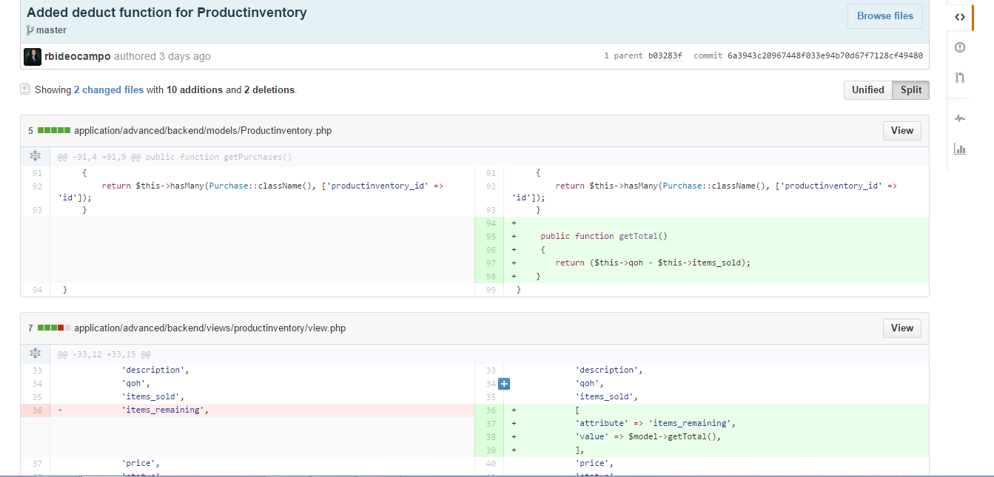

*Pauline – deduct function*

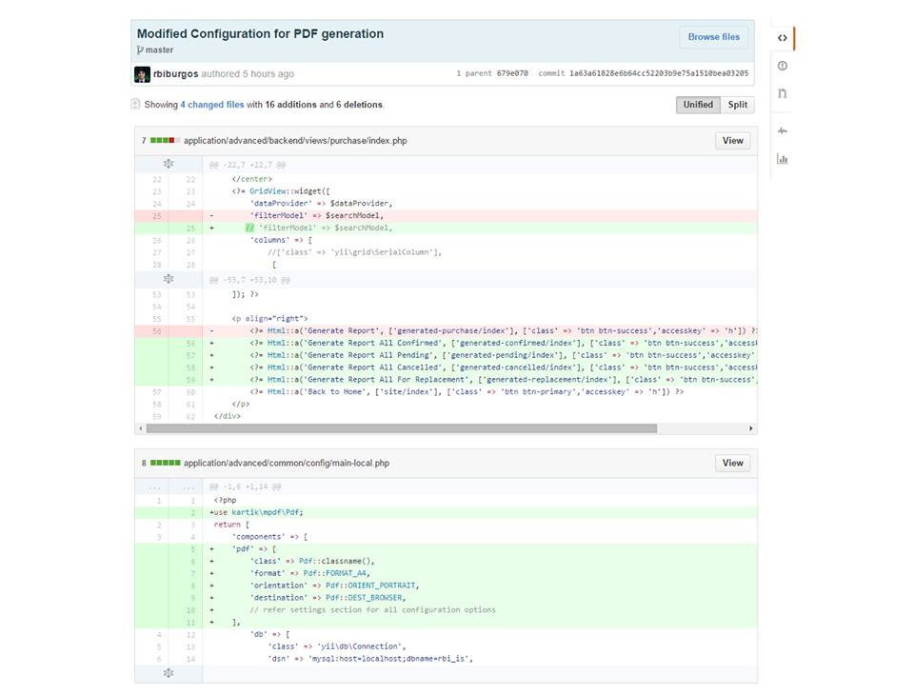

*Phil – Generate PDF*

# CURRENT STATUS OF THE PROJECT

## Percent Completed

90% of the Inventory System project is completed.

## Remaining Work to Be Completed

Only the filter for Date for the Generate PDF function needs to be done.

## Client Feedback Regarding their Interest

The client believes that the Inventory System would be very useful for both sighted and visually-impaired. They were very satisfied and they said are interested in implementing the project. (Comment from the last Iteration).

# NEXT STEPS TO TAKE

* + - Revisions for the Inventory System (if any)
    - Remaining work to be done
    - Final presentation with client (Iteration 3)
    - Continue doing User Manual

|  |
| --- |
|  |